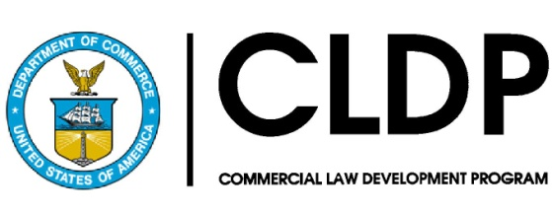

International Contracts and Dispute Resolution in a New Era: Navigating the Good, Bad and Unknown of Technology and Artificial Intelligence

February 15, 2024

Podgorica, Montenegro

Presented by

United States Department of Commerce
Commercial Law Development Program (CLDP)

U.S. Embassy Podgorica
\

In cooperation with

University of Montenegro

Project made possible through funding by the
United States Department of State
Agenda

09:30-10:00 | Registration and welcome coffee
10:00-10:15 | Welcome Remarks  Shamiram Lazar, International Program Specialist, U.S. Department of Commerce Commercial Law Development Program (CLDP)  Ambassador Judy Rising Reinke, U.S. Embassy in Montenegro  Prof. Dr. Aneta Spaić, the Dean of the Faculty of Law at the University of Montenegro
10:15-10:30 | Introduction of the 2024 Vis Moot teams
10:30 - 12:00 | Contract Negotiation and Implementation in the Age of Technology  Prof. Toni Deskoski, St. Cyril and Methodius University Skopje  Prof. Andre Janssen, Radboud University Nijmegen, The Netherlands  Q&A and discussion moderator: Nikolina Tomović, Faculty of Law University of Montenegro
12:00-13:00 | Lunch
13:00-14:00 | The Many Faces of Technology and Artificial Intelligence in International Arbitration: How Much is Too Much?  Arne Fuchs, Ashurst  Vasilije Grgurević, Moravčević Vojnović and partners in cooperation with Schoenherr  Q&A and discussion moderator: Fahira Brodlija, GIZ
14:00-15:30 | The Future of Investor-State Dispute Settlement: Can Technology Make a Difference in the Improvement of the System? (book promotion)  Fahira Brodlija, GIZ  Arne Fuchs, Ashurst  Moderator: Nikolina Tomović, Faculty of Law University of Montenegro
15:30-15:45 | Closing remarks
15:45-17:00 | Coffee break & Networking event

